### Session 10 – Exercise Week 10: Maps and Geospatial Visualization

### Topics covered

* Build visualizations based on geographic data
  + Find insight in provided datasets.
  + Create different maps based on the data.
  + Create views based on date dimension

### To Do

* Use maps and geospatial data to get insight.

### Instructions

Open “Visual Analytics PGR110 - Session 10 – Starter”, which includes the required data sources.

### Chart one – Total passengers in European airports in 2019

1. Create a new sheet, rename it to “European Airports”.
2. Use dataset “Airports (European Airports 2019)”.
3. Rename and fix data.
   1. Rename “Iata” to “Airport Code”.
      1. Change geographic role to “Airport”
   2. Rename “Name” to “Airport Name”.
   3. Change geographic role to “Country/Region” for “Country”.
4. Add “Country” to Detail and there will be a map with one circle for each Country with a data point (minimum one airport).
5. Add “Airport Code” to detail and “Airport Name” to Label.
6. Observe and fix the “1 unknown” (right, bottom of the map).
   1. Edit Locations.  
      Change the Unrecognized “MADMAD” to “MAD”
7. Add “2019 Passengers” to Size and Color.
8. Change Color, Opacity = 75%, add black border.
9. Change map background (“Map” form menu line, “Background Maps”).
   1. Test the different options, end up with “Outdoors”.
   2. Test the zoom functionality:
   3. 
   4. Use the Spy Glass and find your local city/airport. Reset filter/zoom.
10. Change Map Layers (“Map” from menu line, “Map Layers..”).
    1. Tick off “State/Province Borders” and “State/Province Names”.
       1. If they are greyed out, zoom in till it’s possible to click.
11. Filter to the top 5 biggest airports.
    1. Add a filter for “Airport Name” to “Filters”.  
       Select “Top” filter, choose “by field”, choose 5. Base this on “2019 Passengers” (not the default “2018 passengers”.
    2. Observer the filter work to only show top 5.
12. Annotate top 1 with the text “Top 1 Airport 2019”
    1. 
13. Add Caption (Worksheet Menu, “Show Caption”.
14. Export the visualization.
    1. Worksheet from Menu Line, Export, Image.
    2. Paste it into PowerPoint/KeyNote/Word/Pages or similar.
15. Save the workbook.

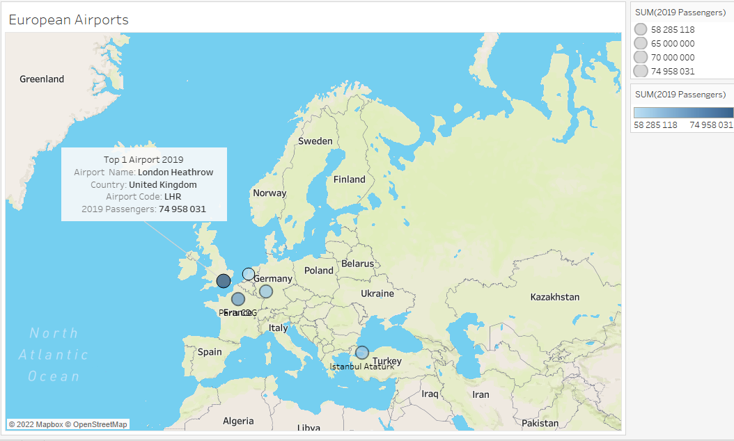

### Chart two– City Bikes

1. Create a new sheet, rename it “City Bikes”.
2. Connect to data source, Spatial datatype (downloaded from Canvas, remember to Unzip the file!): “Oslo Bydeler.shp”.
   1. Add “Geometry” to Detail.
   2. Add “Bydel” to color and label.
3. Connect to data source, Text file datatype (downloaded from Canvas): “Bysykkeldata mars 2022.csv”.
   1. Data collected from: <https://oslobysykkel.no/apne-data>
   2. In Data Pane, create a new Calculated Field, name it “Start Station”.
   3. Formula: MAKEPOINT([start_station_latitude],[start_station_longitude]).
   4. Click “OK”.
4. Drag “Start Station” to the map until you see “Add a Marks Layer”. Drop the field there.
   1. On the Marks Card, “Start Station” tab. Add “start_station_name” to label and “duration” to Size.
5. From the “Oslo bydeler” data source, add a Single Value list-filter on “Bydel”
   1. Filter to “Sentrum”.
6. From “Start Station” on Marks Card, remove the tick for “Add to Zoom Extent”
   1. Graphical user interface, application

      Description automatically generated
7. Chart, map

   Description automatically generated
8. Save the workbook.
9. Bonus: Add “End Station” and “Travel Path” from start to end stations
10. Duplicate the “City Bikes” sheet, rename the copy to “City Bikes: Bonus”.
11. In Data Pane, create a new Calculated Field, name it “End Station”.
    1. Formula: MAKEPOINT([end_station_latitude],[end_station_longitude]).
    2. Click “OK”.
12. Drag “End Station” to the map until you see “Add a Marks Layer”. Drop the field there.
    1. On the Marks Card, “End Station” tab. Add “end_station_name” to label.
13. In Data Pane, create a new Calculated Field, name it “Travel Path”.
    1. Formula: MAKELINE([Start Station], [End Station]).
    2. Click “OK”.
14. Drag “Travel Path” to the map until you see “Add a Marks Layer”. Drop the field there.
    1. Add a Single Value-filter from “Bysykkeldata mars 2022” on “start_station_name”. Remove the “All” option.
15. Test the filters.
16. Save the workbook.
17. A picture containing text, map, indoor

    Description automatically generated

### Chart three + four – City Bikes - dates

1. Create a new sheet, rename it “City Bikes Duration per Weekday”.
2. Use data source “Bysykkeldata mars 2022”
   1. Change datatype for “started_at” to DateTime.
3. In Data Pane, create a new Calculated Field, name it “Duration in Min”.
   1. Formula: [duration]/60
   2. Click “OK”
4. Add the Average of “Duration in Min” to Rows.
5. Add “started_at” to Columns, change to Weekday. Graphical user interface, application

   Description automatically generated
6. On Marks Card, change from Automatic to Bar.
7. Add a new copy of “started_at” to Columns, after the existing blue pill.
8. Change it to “Day (May 8, 2015)”, by right-clicking on the blue pill on Columns.
9. Right click again on the (now) green pill, change from Continuous to Discrete. The pill changes color to blue again.
10. Chart, bar chart

    Description automatically generated
11. Create a new sheet, rename it to “City Bikes Duration”.
12. Add Average of “Duration in Min” to Rows.
13. Add “started_at” to Columns, change to “Day (May 8, 2015)”, by right-clicking on the green pill on Columns.
14. Chart, line chart

    Description automatically generated

Bonus:

Create a new Dashboard, experiment by adding several different sheets and add interactivity.

Example:

